Building a Continuous Integration with Jenkins and Docker

Contents
Prerequisite: 1
Jenkins + DInD (Docker – In – Docker): 1
Jenkins + DOOD (Docker – Outside – Of – Docker): 1
Advantages: 1
Install Jenkins (with DOOD): 2
Install Private Registry with nginx enabled (for proxy): 3
Jenkins jnlp slave agents set up: 5
Jenkins Workflow 7
Build Graph View 7
Build Pipeline View 12
Pipeline is preferable over Graph view 15

Prerequisite:
- Install Ubuntu
- Install Docker

Jenkins + DInD (Docker – In – Docker):
- This includes Docker installation inside of Jenkins.
- This maintains the created containers as children.
- This would be preferable if want to manage a complete clean Docker environment inside Jenkins.

Jenkins + DOOD (Docker – Outside – Of – Docker):
- This uses underlying host’s Docker installation.
- This maintains the created containers as siblings.

Advantages:
- Enables sharing of images with host OS
  - Eliminates storing images multiple times
  - Makes it possible for Jenkins to automate local image creation
- Eliminates a virtualization layer (lxc)
- Any settings in the host’s Docker daemon will apply to Jenkins container as well
- Easier to set up, just need to map the host’s Docker executable and daemon socket on to the container
- Host and Jenkins container will use the same version of Docker, always.
- No privileged mode needed
- Permits the jenkins user to run docker without the sudo prefix.
- Allows greater flexibility at runtime.
- Ability to reuse the image cache from the host.

Note: In general, for testing and production environment, DOOD is chosen instead of DinD

Install Jenkins (with DOOD):

- Create a file with name “Dockerfile” and fill with the below content
FROM jenkins:latest
MAINTAINER Kranthi Kumar Bitra <kranthi.b76@gmail.com>

USER root
RUN apt-get update \
&& apt-get install -y sudo supervisor \
&& rm -rf /var/lib/apt/lists/*

RUN curl -sSL https://get.docker.com/ | sh

RUN usermod -aG docker root

USER root
RUN mkdir -p /var/log/supervisor
RUN mkdir -p /var/log/jenkins
COPY supervisord.conf /etc/supervisor/conf.d/supervisord.conf
CMD /usr/bin/supervisord -c /etc/supervisor/conf.d/supervisord.conf
- Create a file with name “supervisord.conf” , fill with the below content
[supervisord]
user=root
nodaemon=true

[program:chown]
priority=20
command=chown -R root:root /var/jenkins_home

[program:root]
user=root
autostart=true
autorestart=true
command=/usr/local/bin/jenkins.sh
redirect_stderr=true
stdout_logfile=/var/log/jenkins/%(program_name)s.log
stdout_logfile_maxbytes=10MB
stdout_logfile_backups=10
environment = JENKINS_HOME="/var/jenkins_home",HOME="/var/jenkins_home",USER="root"
- Create a file with name “plugins.txt” , fill with the below content
structs:latest
workflow-step-api:latest
workflow-scm-step:latest
scm-api:latest
scm-sync-configuration:latest
credentials:latest
mailer:latest
junit:latest
subversion:latest
script-security:latest
matrix-project:latest
ssh-credentials:latest
git-client:latest
git:latest
greenballs:latest
ssh-slaves:latest
token-macro:latest
durable-task:latest
docker-plugin:latest

- Create a file with name “docker-compose.yml”, fill with the below content
myjenkins:
image: myjenkins_dood
volumes:
- /var/run/docker.sock:/var/run/docker.sock
- ./jenkins_home:/var/jenkins_home
ports:
- "8080:8080"
- "50000:50000"
- In command prompt, go to the directory where the above four files exists, execute the below commands to start Jenkins with DOOD.
  - docker build –t myjenkins-dood . (this will take few minutes time to build the image – only one time should execute)
  - docker-compose up

Install Private Registry with nginx enabled (for proxy):

- Create a directory with name “docker-registry”
- Go to directory – “docker-registry” , create two sub directories – “nginx” and “data”
- In “docker-registry” folder, create a file with name “docker-compose.yml”, fill with the below content
nginx:
image: "nginx:latest"
ports:
- 5043:443
links:
- registry:registry
volumes:
- ./nginx/:/etc/nginx/conf.d
registry:
image: registry:2
ports:
- 5000:5000
environment:
REGISTRY_STORAGE_FILESYSTEM_ROOTDIRECTORY: /data
volumes:
- ./data:/data
- Go to the “nginx” folder, create a file with name “registry.conf”, fill with the below content
upstream docker-registry {
server registry:5000;
}

server {
listen 443;
server_name myregistrydomain.com;

# SSL
# ssl on;
# ssl_certificate /etc/nginx/conf.d/domain.crt;
# ssl_certificate_key /etc/nginx/conf.d/domain.key;

# disable any limits to avoid HTTP 413 for large image uploads
client_max_body_size 0;

# required to avoid HTTP 411: see Issue #1486 (https://github.com/docker/docker/issues/1486)
chunked_transfer_encoding on;

location /v2/ {
# Do not allow connections from docker 1.5 and earlier
# docker pre-1.6.0 did not properly set the user agent on ping, catch "Go *" user agents
if ($http_user_agent ~ "^(docker\/1\.(3|4|5(?!\.[0-9]-dev))|Go ).*$" ) {
return 404;
}

# To add basic authentication to v2 use auth_basic setting plus add_header
# auth_basic "registry.localhost";
# auth_basic_user_file /etc/nginx/conf.d/registry.password;
# add_header 'Docker-Distribution-Api-Version' 'registry/2.0' always;

proxy_pass http://docker-registry;
proxy_set_header Host $http_host; # required for docker client's sake
proxy_set_header X-Real-IP $remote_addr; # pass on real client's IP
proxy_set_header X-Forwarded-For $proxy_add_x_forwarded_for;
proxy_set_header X-Forwarded-Proto $scheme;
proxy_read_timeout 900;
}
}
- Go to “docker-registry” folder , execute the below command to run the private registry
  - docker-compose up

Jenkins jnlp slave agents set up:

- Create a node by accessing the Jenkins Master URL. (Make a copy of the slave node name and the secret key generated on creation of node)
- Create a file with name “Dockerfile” and fill with the below content
FROM java:8-jdk
MAINTAINER Kranthi Kumar Bitra <kranthi.b76@gmail.com>

ENV HOME /var/jenkins_home
RUN useradd -c "Jenkins user" -d $HOME -m jenkins
RUN usermod -G users jenkins

USER root
RUN apt-get update \
&& apt-get install -y sudo supervisor \
&& rm -rf /var/lib/apt/lists/*

RUN curl -sSL https://get.docker.com/ | sh
RUN usermod -aG docker jenkins

USER root
RUN mkdir -p /var/log/supervisor
RUN mkdir -p /var/log/jenkins
COPY supervisord.conf /etc/supervisor/conf.d/supervisord.conf
CMD /usr/bin/supervisord -c /etc/supervisor/conf.d/supervisord.conf

RUN curl -A "Mozilla/5.0" --create-dirs -sSLo /usr/share/jenkins/slave.jar http://repo.jenkins-ci.org/public/org/jenkins-ci/main/remoting/2.53/remoting-2.53.jar && chmod 755 /usr/share/jenkins && chmod 644 /usr/share/jenkins/slave.jar

COPY jenkins-slave /usr/local/bin/jenkins-slave

WORKDIR /var/jenkins_home
USER jenkins
- Create a file with name “supervisord.conf” , fill with the below content
[supervisord]
user=root
nodaemon=true

[program:chown]
priority=20
command=chown -R jenkins:jenkins /var/jenkins_home

[program:jenkins]
user=jenkins
autostart=true
autorestart=true
command=/usr/local/bin/jenkins.sh
redirect_stderr=true
stdout_logfile=/var/log/jenkins/%(program_name)s.log
stdout_logfile_maxbytes=10MB
stdout_logfile_backups=10
environment = JENKINS_HOME="/var/jenkins_home",HOME="/var/jenkins_home",USER="jenkins"
- Create a file with name “docker-compose.yml”, fill with the below content
myjenkinsAgent:
image: myjenkins_dood_jnlp_agent
command:
Jenkins Master URL
Name of the Slave node created in Master Jenkins
java -jar /usr/share/jenkins/slave.jar -jnlpUrl http://172.16.101.93:8080/computer/test-agent/slave-agent.jnlp -secret 4f9b27619dc67a88161e05d6afe36b0508643b74989e5cf29e80c89ace3075a8
Slave Node secret key generated while creating node in Master Jenkins
volumes:
- /usr/local/bin/docker:/bin/docker
- /var/run/docker.sock:/var/run/docker.sock
- In command prompt, go to the directory where the above three files exists, execute the below commands to start Jenkins slave as a jnlp agent.
  - docker build –t myjenkins-dood_jnlp_agent . (this will take few minutes time to build the image – only one time should execute)
  - docker-compose up

Jenkins Workflow

Build Graph View

- Job to create artefact for the “product catalogue” spring-boot project.

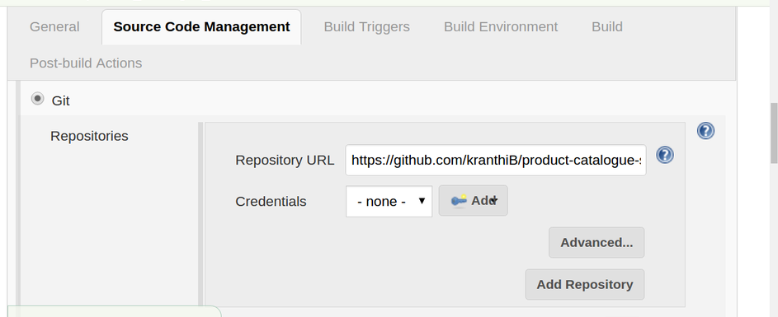
- Source Code Management – Given the Git Project URL

- Build Triggers – This get executed whenever a change is pushed to GitHub

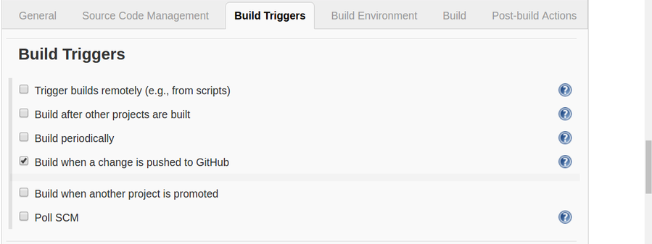

- Build – Create a jar for spring-boot project
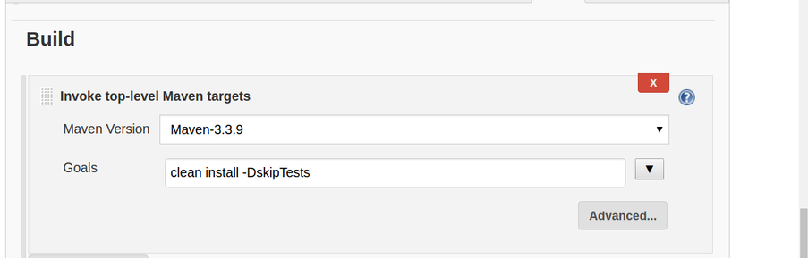

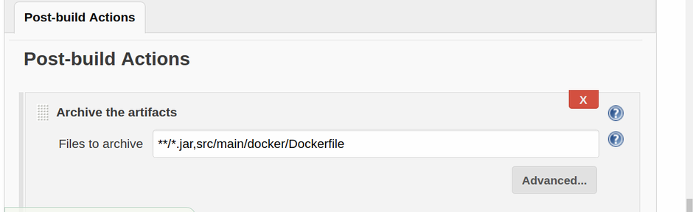
- Post-build Actions – will archive the artefacts which will be used by successor Jenkins jobs

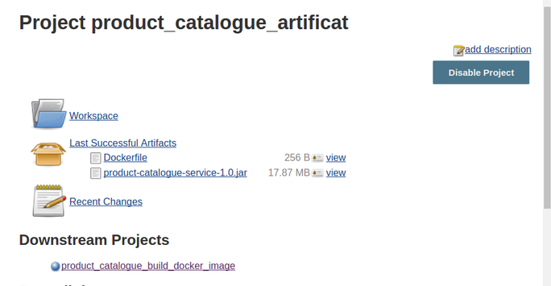

- Job to build docker image for the “product catalogue” spring-boot project.

- Build Triggers – This will get executed only when the above artefact project build is stable

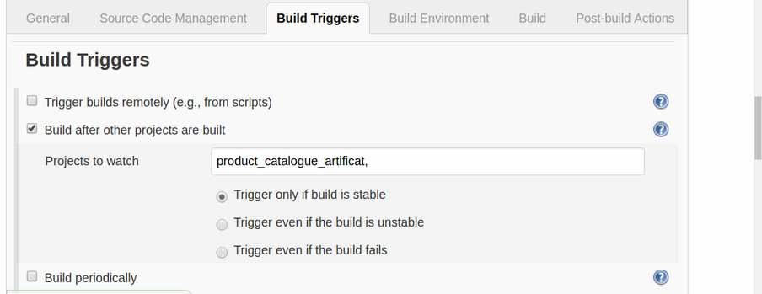

- Build - Copying artefacts generated from the previous project
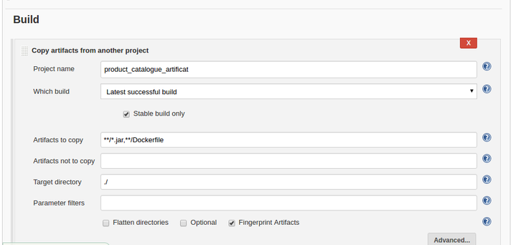

- Build – Build docker image for the product-catalogue project

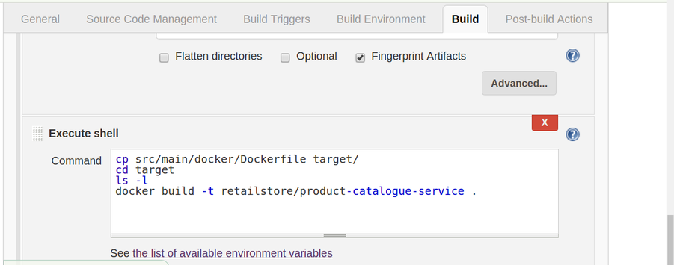



- Job to publish the docker image to private registry

- Build Triggers – This will get executed only when the above build docker image is stable

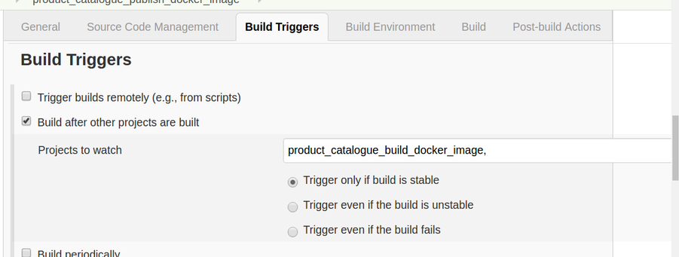

- Build – publish image to docker registry

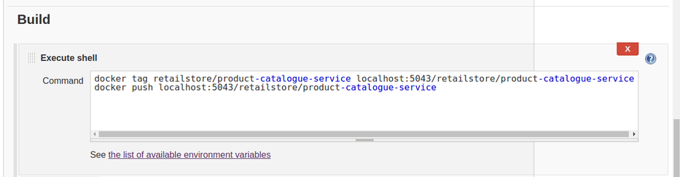



- Job to run the project as docker container from the published image of docker registry

- Build Triggers - This will get executed only when the above publish docker image is stable

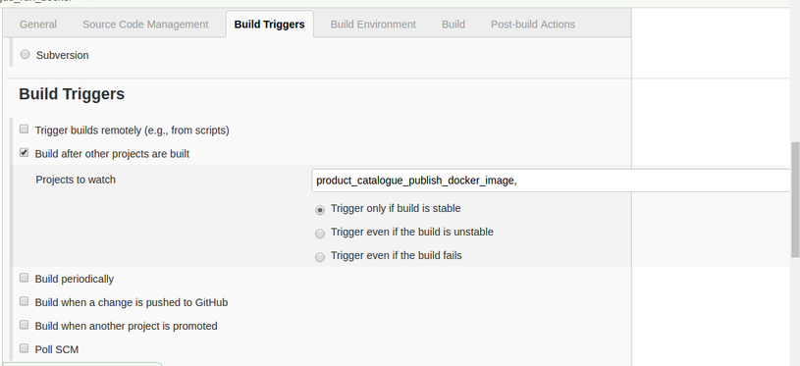

- Build – run the published image from docker registry
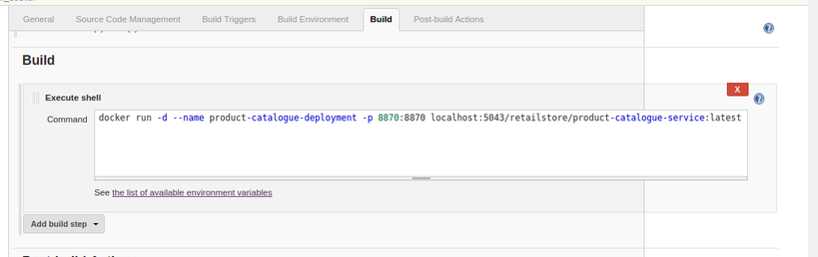


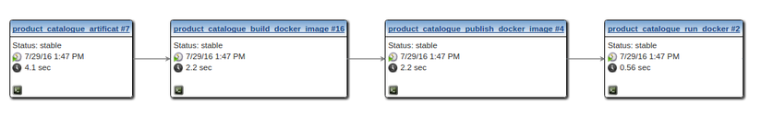
- Build Graph View

Build Pipeline View
- Instead of “Freestyle project”, select project type as “Pipeline”
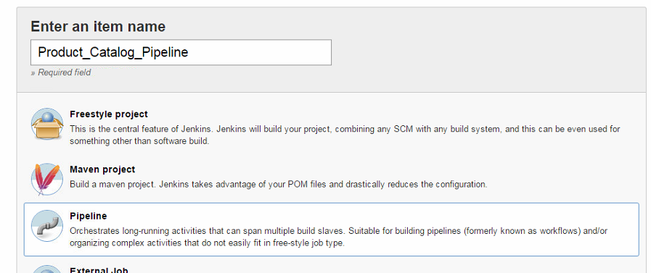

- Under “Build Triggers” tab, select the option “The project is parameterized” and add a parameter by selecting type as “Node”. Here, we can ensure how many nodes can be involved while executing a pipeline as below
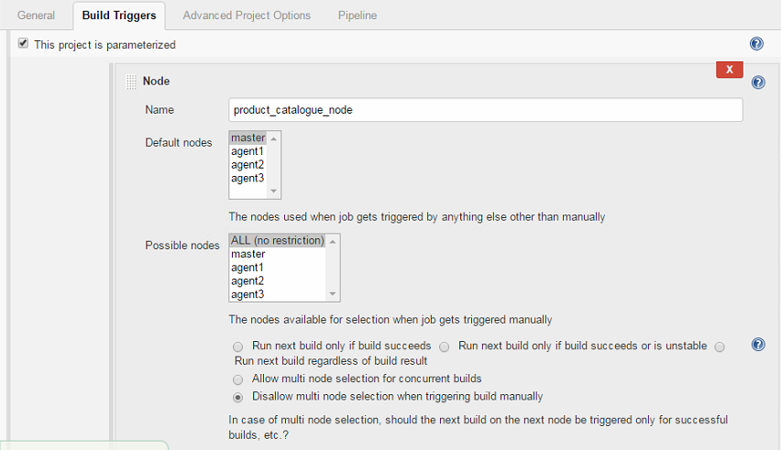
- Write the pipeline script with clear functionality to be performed at each stage of the workflow
“agent1” is the name of the slave node which is an option to specify while writing the pipeline script
stage 'Create artifact'
node ('agent1’'){
git url: 'https://github.com/kranthiB/product-catalogue-service.git'
def mvnHome = tool 'Maven_3.3.9'
sh "${mvnHome}/bin/mvn clean install -DskipTests"
}
If we don’t specify the slave node then master will dynamically pick the slave node (depending on high availability) and complete the respective stage

stage 'Archive artifact'
node{
archive '**/*.jar,**/Dockerfile'
}

stage 'Build Docker Image'
node('agent3') {
sh "pwd"
sh "cp ~/workspace/Product_Catalogue_Pipeline/target/product-catalogue-service-1.0.jar ~/workspace/Product_Catalogue_Pipeline/"
sh "docker build -f ~/workspace/Product_Catalogue_Pipeline/src/main/docker/Dockerfile -t retailstore/product-catalogue-service ."
}

def tasks = [:]
stage 'Run Integration Tests'
tasks["Integrations Tests"] = {
node {
sh 'echo Integration Tests Done'
}
}
stage 'Run Selenium Tests'
tasks["Selenium Tests"] = {
node {
sh 'echo Selenium Test Done'
}
}
stage 'Run Sonar'
tasks["Sonar"] = {
node {
sh 'echo Sonar Done'
}
}

parallel tasks

stage 'Publish Docker Image'
node {
sh "docker tag retailstore/product-catalogue-service localhost:5043/retailstore/product-catalogue-service"
sh "docker push localhost:5043/retailstore/product-catalogue-service"
}

stage 'Run Docker Image'
node{
sh "docker run -d --name product-catalogue-deployment -p 8870:8870 localhost:5043/retailstore/product-catalogue-service"
}
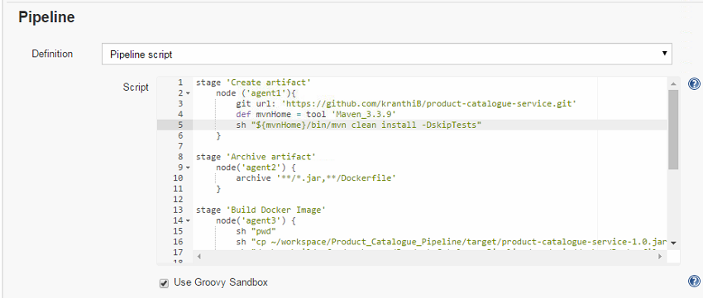

- Build Pipeline View
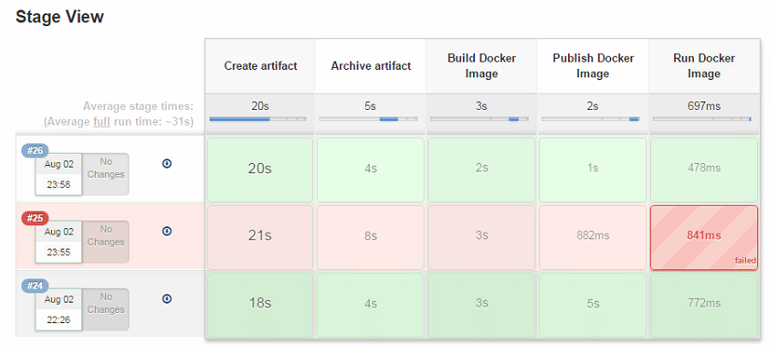

Pipeline is preferable over Graph view
- In a single pipeline job, we can specify all stages of our workflow where as in Graph view each stage of the flow will be one "Freestyle job"
- In Pipeline view , that master will be dynamically choose the slave node to run a particular stage depending on the high availability where as in Graph view we have the specify statically the slave node which is fixed

